**Mr. JAYDATT TANAJI DHORSINGE.**

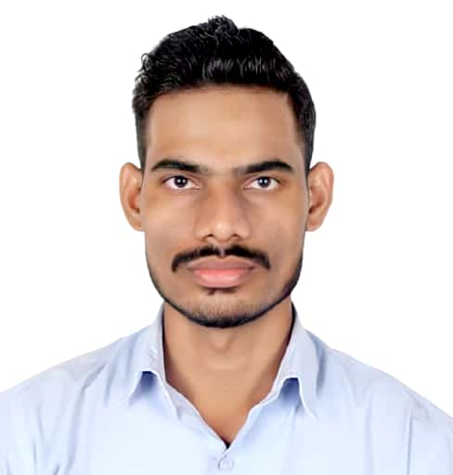

BE Mechanical Engineering

Employer : *Cognizant Technology Solutions India Pvt. Ltd*

Email: [*jaydattd98@gmail.com*](mailto:jaydattd98@gmail.com)

Ph: +*91-9158224033*

GitHub : - *https://github.com/jaydattd98*

LinkedIn **: -**<https://www.linkedin.com/in/jaydatt-dhorsinge-073047159>

|  |
| --- |
| **Professional Experience** |

* **Full Stack Developer**

***Cognizant Technology Solutions India Pvt. Ltd, Pune.***

*Nov-2020 -present*

Working as **Full Stack Developer** in **Lending** **services** form client location which is one of the well know **Swiss Bank (Credit Suisse, Pune).**

* Built end to end **Rest API which includes creation of Service, Repository, Helper, and Mapper**.
* **Built the web client to consume soap services**.
* **Implemented the Email Notification service** to send notifications.
* **Built Schedular Service to update database Daily and Monthly**.
* Resolved most of the bug in an application and improved the user experience.
* Added JUnit test cases and increased overall code coverage of an application by more than 60%, Which include each class coverage greater than 85 %.
* Implemented service to dynamically create of request XML for webservice using Free Marker template which **reduced almost 10% of previous overall code**.
* **Intern**

***Cognizant Technology Solutions India Pvt. Ltd, Pune.***

*Dec-2019 to June-2020*

Successfully completed 6 months Internship in **Java Full Stack.**

* Learnt full stack technology like Java, Spring Boot, Angular, MySQL.
* Built Rest APIs using spring boot for projects.
* Learnt the proper way of exception handling.
* Lernt use of Java 8 feature like Stream and Lamba.
* Presented the created Application to team which is also got appreciated by team.
* Learnt concept like lazy loading using angular routing.
* Learnt how to add spring security like JWT.

|  |
| --- |
| **Technical Skills** |

**Java 8+**, **Spring Boot, JPA, Hibernate, Stream API and Lamb Expression, Exception handling, Angular2+,** HTML, CSS, JavaScript, MySQL, **Kafka**(producer/consumer), Knowledge of Logstash, Elastic Search, Kibana**, Jenkins, GIT, SonarQube, Docker. AWS (RDS, ECS, S3, EC2, Code Star used all service for project)**

|  |
| --- |
| **Additional Skills** |

* I have participated and aware of all sorts of **Agile Ceremonies** (user story grooming, sprint planning and retrospective).
* Able to groom user stories and make accurate estimates through **story points.**
* Good Analytical and team working skills.

|  |  |  |  |  |  |
| --- | --- | --- | --- | --- | --- |
| **Education Qualification** | | | | | |
| **Course** | **Institute** | | **University/Board** | **Percentage/**  **CGPA** | **Year of Passing** |
| **B.E - Mechanical** | | Sinhgad Institute Of Technology, Lonavala. | Savitribai Phule  Pune University | 8.44 | 2020 |
| **HSS** | | M.V.Jr college of science. | State Board | 78.77 | 2016 |
| **SSC** | | P.V. Aary Vidhaylaya | State Board | 86.60 | 2014 |

|  |
| --- |
| **Personal Project** |

* **Tweet-App:** -

**Objective** :- To build and deploy an appliaction which is stable, faster and can handle all uncertainties with proper error massage and status code.

**Git link** :- <https://github.com/jaydattd98/tweetapp>

**Application link** :- <http://tweet-app-ui-jaydatt.s3-website-us-west-1.amazonaws.com/home>

**Swagger link** :- <http://13.57.179.254:9191/swagger-ui/index.html#/>

**Details** :-

* Implemented **custom exception handling with error code*.***
* Implemented **AOP for logging**.
* Implemented **open api for documentation** of resources.
* Implemented **kafka producer** for delete functionality.
* **Configured Logstash, Ealstic Serach, Kibana for logging purpose**.
* Used java 8 features like **Optional class**, **Stream api and Lambda Expression**.
* Built DTO object for Request and Response.

**Technology :- Angular, Java, Spring Boot, MySQL. Kafka, Open API (swagger),**

**Logstash, Elastic Search, Kibana.**

|  |
| --- |
| **Internship Projects** |

* **Air-Ticket-Reservation :-**

**Discription**:-

This project is web application which facilitetes the online booking of flights. This application allows Admin and customer to perform different operations like Flight Search, Book ticket, cancel flight, Edit details etc. This project final objective to develop an application which can be used to manage customers and flight details.

**Technology**:- Database: MySQL, Scripting: JavaScript, Java : Java, Spring MVC, Spring Boot.

* **Tru-Yum** :-

**Discription**:-

This project is web application which facilitetes the online ordering of food.This application allows admin and customer to perform different operations like Add Menuitems, Delete MenuItems,Add To Cart, Remove from Cart etc. Final objective of this project is to develop an application which can be used to manage the customer order and menu items details.

**Technology**:- Database: MySQL, Scripting: JavaScript, Java : Java, Spring MVC, Spring Boot.

|  |
| --- |
| **Academic Project** |

* **Self-Locking Electronic Differential Gear Box: -**

**Discription** :-

This project make the vehicle successfully move out when it get stuck in mud or from any slippery surface.This modification in differntial provide the equal amount of power to both wheel by automatic detecting the slippery condition and engaging the wheel.

**Tools**:- Design: CATIA V5 R20, Analysis: ANSYS 18.0.

**Role**: - To set design parameters and do the analysis of model using ANSYS 18.0.

|  |
| --- |
| **Declaration** |

I hereby declare that the particulars given here are true to the best of my knowledge and belief.

Date:

Place: Pune

Yours sincerely,

Jaydatt T. Dhorsinge.